LEARNER WORKBOOK
FULL NAME & SURNAME

ID NUMBER:

NAME OF ASSESSOR

DATE OF ASSESSMENT

VENUE

ACHIEVED |  |  | NOT ACHIEVED
KNOWLEDGE
SKILLS

Signature of learner Signature of Assessor
In terms of the Copyright Act 1978:

No part of this manual may be reproduced or translated in any form or by any means, electronic or mechanical including photocopying, recording or by an information storage and retrieval system without the express permission from TDA.

COPYRIGHT: TRAINING DYNAMICS AFRICA
First edition 2008

Publications disclaimer

Neither the authors nor the SETA can accept any responsibility for any legal or any other consequences, which may arise directly or indirectly as a result of the use or adaptation of or reliance upon any of the content of this material.

This material has been compiled based on the UNIT STANDARD 244189 CONDUCT ACCESS AND EGRESS CONTROL.

The program has been accredited by SASSETA in the Republic of South Africa.

Material compiled by: Training Dynamics Africa

HOW THIS LEARNER WORKBOOK IS COMPILED

This learner workbook has been compiled to equip learners with the necessary skill, knowledge and attributes that will enable them to man an access control point. They will also be able to execute access control duties in a manner that will contribute towards the safety of an organisation or environment.

A person credited with this unit standard will be able to:

- Explain access and egress control functions.
- Control people, vehicles and materials at an access and egress control point.
- Search people, goods and vehicles.
- Escort authorized persons and vehicles.

You have to study the content and guidelines given in your learner reference guide to complete this workbook.

Remember that this completed workbook must be handed in as it will form part of your formative assessment and will play a role in awarding you the required 07 credits that are to be achieved upon completion of this module.

Write neatly and legibly and ensure that you do not simply copy the information contained in the learner reference guide into your workbook. Give your own opinion and ideas where applicable and write the answers in your own words to indicate your level of understanding and learning.

Good luck with the completion of this workbook.

LEARNING UNIT 1

Access and Egress Control

LEARNING OUTCOMES

A learning credited with this unit will be able to:

- Define access control.
- Explain the purpose for access control.
- Explain the objectives of access control and egress control.
- Explain the meaning of outer layer protection.
- Identify and demonstrate knowledge and skills in the use of the various access control methods/aids.
- Identify and demonstrate knowledge and skills in the use of the various access control identification system.
- Explain the relation between access control measures and internal and external threats.
- Explain the role of access control in the event of an emergency.

LEARNER ACTIVITY 1

Explain the purpose of having access control and egress control functions at a building.
_______________________________________________________________________
_______________________________________________________________________
_______________________________________________________________________
_______________________________________________________________________
_______________________________________________________________________
_______________________________________________________________________
_______________________________________________________________________
_______________________________________________________________________
Requirements achieved | YES |  | NO
Comments in support of decision
_______________________________________________________________________
_______________________________________________________________________
_______________________________________________________________________
_______________________________________________________________________
_______________________________________________________________________
_______________________________________________________________________
_______________________________________________________________________

LEARNER ACTIVITY 2

Explain the objectives of access control.
_______________________________________________________________________
_______________________________________________________________________
_______________________________________________________________________
_______________________________________________________________________
_______________________________________________________________________
_______________________________________________________________________
_______________________________________________________________________
_______________________________________________________________________
Requirements achieved | YES |  | NO
Comments in support of decision
_______________________________________________________________________
_______________________________________________________________________
_______________________________________________________________________
_______________________________________________________________________
_______________________________________________________________________
_______________________________________________________________________
_______________________________________________________________________

LEARNER ACTIVITY 3

Explain the objectives of egress control.
_______________________________________________________________________
_______________________________________________________________________
_______________________________________________________________________
_______________________________________________________________________
_______________________________________________________________________
_______________________________________________________________________
_______________________________________________________________________
_______________________________________________________________________
Requirements achieved | YES |  | NO
Comments in support of decision
_______________________________________________________________________
_______________________________________________________________________
_______________________________________________________________________
_______________________________________________________________________
_______________________________________________________________________
_______________________________________________________________________
_______________________________________________________________________

LEARNER ACTIVITY 4

Provide a detail explanation of at least four outer layers of protection.

Demonstrate your understanding by providing three examples of each which can be found at your workplace.
_______________________________________________________________________
_______________________________________________________________________
_______________________________________________________________________
_______________________________________________________________________
_______________________________________________________________________
_______________________________________________________________________
_______________________________________________________________________
_______________________________________________________________________
_______________________________________________________________________
_______________________________________________________________________
_______________________________________________________________________
_______________________________________________________________________
_______________________________________________________________________
_______________________________________________________________________
_______________________________________________________________________
_______________________________________________________________________ _______________________________________________________________________
_______________________________________________________________________
_______________________________________________________________________
_______________________________________________________________________
_______________________________________________________________________
_______________________________________________________________________
_______________________________________________________________________

Requirements achieved | YES |  | NO
Comments in support of decision
_______________________________________________________________________
_______________________________________________________________________
_______________________________________________________________________
_______________________________________________________________________
_______________________________________________________________________
_______________________________________________________________________

LEARNER ACTIVITY 5

Explain three identification system that can be used to offer effective access and egress control.
_______________________________________________________________________
_______________________________________________________________________
_______________________________________________________________________
_______________________________________________________________________
_______________________________________________________________________
_______________________________________________________________________
_______________________________________________________________________
_______________________________________________________________________
_______________________________________________________________________
_______________________________________________________________________
_______________________________________________________________________
_______________________________________________________________________
_______________________________________________________________________
_______________________________________________________________________
_______________________________________________________________________
_______________________________________________________________________
_______________________________________________________________________ _______________________________________________________________________
_______________________________________________________________________
_______________________________________________________________________
_______________________________________________________________________
_______________________________________________________________________
_______________________________________________________________________
_______________________________________________________________________

Requirements achieved | YES |  | NO
Comments in support of decision
_______________________________________________________________________
_______________________________________________________________________
_______________________________________________________________________
_______________________________________________________________________
_______________________________________________________________________
_______________________________________________________________________

LEARNER ACTIVITY 6

Discuss the role of access control officers during an emergency situation.
_______________________________________________________________________
_______________________________________________________________________
_______________________________________________________________________
_______________________________________________________________________
_______________________________________________________________________
_______________________________________________________________________
_______________________________________________________________________
_______________________________________________________________________
_______________________________________________________________________
_______________________________________________________________________
_______________________________________________________________________
_______________________________________________________________________
_______________________________________________________________________
_______________________________________________________________________
_______________________________________________________________________
_______________________________________________________________________
_______________________________________________________________________ _______________________________________________________________________
_______________________________________________________________________
_______________________________________________________________________
_______________________________________________________________________
_______________________________________________________________________
_______________________________________________________________________
_______________________________________________________________________

Requirements achieved | YES |  | NO
Comments in support of decision
_______________________________________________________________________
_______________________________________________________________________
_______________________________________________________________________
_______________________________________________________________________
_______________________________________________________________________
_______________________________________________________________________

SELF-ASSESSMENT

The learner must make use of the following self-evaluation checklist to rate himself against the learning outcomes of this particular training module in establishing the level of mastery of the information.

- Not able to comply

- Reasonable compliance (Not acceptable for final evaluation)

- Able to comply fully
 | LEARNING OUTCOMES | 1 | 2 | 3
1 | Define access control.
2 | Explain the purpose for access control.
3 | Explain the objectives of access control and egress control.
4 | Explain the meaning of outer layer protection.
5 | Identify and demonstrate knowledge and skills in the use of the various access control methods/aids.
6 | Identify and demonstrate knowledge and skills in the use of the various access control identification system.
7 | Explain the relation between access control measures and internal and external threats.
8 | Explain the role of access control in the event of an emergency.

_____________________________________ ________________________ Evidence Collector Signature Date

_____________________________________ ________________________
Security Officer Signature Date

LEARNING UNIT 2

Operating and maintaining access and egress sites.

LEARNING OUTCOMES

A learning credited with this unit will be able to:

- Operate and maintain an access/egress control site in accordance with the relevant legal requirements and workplace procedures.
- Conduct access/egress control of people vehicles and goods per workplace procedure.
- Operate site-specific equipment in accordance with workplace procedures and manufacturer’s specifications.
- Deal with unauthorized/authorized people, vehicles and goods as per workplace procedure and relevant legal requirements.
- Handle emergencies and irregularities according to workplace procedures and contingency plans.
- Ensure appropriate interpersonal skills for effective customer relationships.

LEARNER ACTIVITY 1

As an access control security officer, it is expected of you to control all access and egress to the security area you are protecting. What are the five main aspects to be controlled during access and egress control?
_______________________________________________________________________
_______________________________________________________________________
_______________________________________________________________________
_______________________________________________________________________
_______________________________________________________________________
_______________________________________________________________________
_______________________________________________________________________
_______________________________________________________________________
Requirements achieved | YES |  | NO
Comments in support of decision
_______________________________________________________________________
_______________________________________________________________________
_______________________________________________________________________
_______________________________________________________________________
_______________________________________________________________________
_______________________________________________________________________
_______________________________________________________________________

LEARNER ACTIVITY 2

Work procedures for access and egress control must indicate the following:
_______________________________________________________________________
_______________________________________________________________________
_______________________________________________________________________
_______________________________________________________________________
_______________________________________________________________________
_______________________________________________________________________
_______________________________________________________________________
_______________________________________________________________________
Requirements achieved | YES |  | NO
Comments in support of decision
_______________________________________________________________________
_______________________________________________________________________
_______________________________________________________________________
_______________________________________________________________________
_______________________________________________________________________
_______________________________________________________________________
_______________________________________________________________________

LEARNER ACTIVITY 3

Your security manager approaches you to assist him in thinking of the current and additional measures that can be taken within your access control. There are five possible measures that can be taken. Name the five and give a short description of each.
_______________________________________________________________________
_______________________________________________________________________
_______________________________________________________________________
_______________________________________________________________________
_______________________________________________________________________
_______________________________________________________________________
_______________________________________________________________________
_______________________________________________________________________
Requirements achieved | YES |  | NO
Comments in support of decision
_______________________________________________________________________
_______________________________________________________________________
_______________________________________________________________________
_______________________________________________________________________
_______________________________________________________________________
_______________________________________________________________________
_______________________________________________________________________

LEARNER ACTIVITY 4

Demonstrate your understanding of zoning by draw a picture of a typical floor plan of a building.

Indicate your understanding of zoning on the floor plan.
_______________________________________________________________________
_______________________________________________________________________
_______________________________________________________________________
_______________________________________________________________________
_______________________________________________________________________
_______________________________________________________________________
_______________________________________________________________________
_______________________________________________________________________
_______________________________________________________________________
_______________________________________________________________________
_______________________________________________________________________
_______________________________________________________________________
_______________________________________________________________________
_______________________________________________________________________
_______________________________________________________________________
_______________________________________________________________________
_______________________________________________________________________
_______________________________________________________________________ _______________________________________________________________________
_______________________________________________________________________
_______________________________________________________________________
_______________________________________________________________________
_______________________________________________________________________
_______________________________________________________________________
_______________________________________________________________________
_______________________________________________________________________
_______________________________________________________________________
_______________________________________________________________________

Requirements achieved | YES |  | NO
Comments in support of decision
_______________________________________________________________________
_______________________________________________________________________
_______________________________________________________________________
_______________________________________________________________________
_______________________________________________________________________
_______________________________________________________________________

LEARNER ACTIVITY 5

Complete the attached registers. The assessor will provide you with handouts which consist of valuable information to be used
Requirements achieved | YES |  | NO
Comments in support of decision
_______________________________________________________________________
_______________________________________________________________________
_______________________________________________________________________
_______________________________________________________________________
_______________________________________________________________________
_______________________________________________________________________

I hereby grant permission for an
Authorised officer of ………
to inspect the contents of my v
ehicle or any container I may
have in my possession whilst I am on a site occupied by ……….
Date
Name of visitor/
contractor
Company
Tel:
Who is
being
visited
Vehicle
Register
Per. no
Time
in
Time
out
ID NO.
Hand
Sign

NUMBER: 00049
VISITORS REGISTER

KEY CONTROL REGISTER | Page  of  pages | Received By
KEY CONTROL REGISTER | Page  of  pages | Date Re-  turned
KEY CONTROL REGISTER | Page  of  pages | Issued To:
KEY CONTROL REGISTER | ACTIVITY:
KEY CONTROL REGISTER | ACTIVITY: | Issued  By
KEY CONTROL REGISTER | ACTIVITY: | Date Issued
KEY CONTROL REGISTER | ACTIVITY: | No. of Keys  Issued
KEY CONTROL REGISTER | ACTIVITY: | Location
KEY CONTROL REGISTER | ACTIVITY: | Key Code  Number

LEARNER ACTIVITY 6

Explain a typical access control site procedure that can be found at your workplace.
_______________________________________________________________________
_______________________________________________________________________
_______________________________________________________________________
_______________________________________________________________________
_______________________________________________________________________
_______________________________________________________________________
_______________________________________________________________________
_______________________________________________________________________
_______________________________________________________________________
_______________________________________________________________________
_______________________________________________________________________
_______________________________________________________________________
_______________________________________________________________________
_______________________________________________________________________
_______________________________________________________________________
_______________________________________________________________________
_______________________________________________________________________
_______________________________________________________________________ _______________________________________________________________________
_______________________________________________________________________
_______________________________________________________________________
_______________________________________________________________________
_______________________________________________________________________
_______________________________________________________________________
_______________________________________________________________________

Requirements achieved | YES |  | NO
Comments in support of decision
_______________________________________________________________________
_______________________________________________________________________
_______________________________________________________________________
_______________________________________________________________________
_______________________________________________________________________
_______________________________________________________________________

LEARNER ACTIVITY 7

Entry and exit to premises are usually controlled by an access and egress control system. The functions of such a control system could include the following:
_______________________________________________________________________
_______________________________________________________________________
_______________________________________________________________________
_______________________________________________________________________
_______________________________________________________________________
_______________________________________________________________________
_______________________________________________________________________
_______________________________________________________________________
_______________________________________________________________________
_______________________________________________________________________
_______________________________________________________________________
_______________________________________________________________________
_______________________________________________________________________
_______________________________________________________________________
_______________________________________________________________________
_______________________________________________________________________
_______________________________________________________________________ _______________________________________________________________________
_______________________________________________________________________
_______________________________________________________________________
_______________________________________________________________________
_______________________________________________________________________
_______________________________________________________________________
_______________________________________________________________________

Requirements achieved | YES |  | NO
Comments in support of decision
_______________________________________________________________________
_______________________________________________________________________
_______________________________________________________________________
_______________________________________________________________________
_______________________________________________________________________
_______________________________________________________________________

LEARNER ACTIVITY 8

To control unauthorized and authorized people, vehicles and goods at an access control point, the following guidelines will make it difficult for unwanted persons to gain access to premises:
_______________________________________________________________________
_______________________________________________________________________
_______________________________________________________________________
_______________________________________________________________________
_______________________________________________________________________
_______________________________________________________________________
_______________________________________________________________________
_______________________________________________________________________
_______________________________________________________________________
_______________________________________________________________________
_______________________________________________________________________
_______________________________________________________________________
_______________________________________________________________________
_______________________________________________________________________
_______________________________________________________________________
_______________________________________________________________________
_______________________________________________________________________ _______________________________________________________________________
_______________________________________________________________________
_______________________________________________________________________
_______________________________________________________________________
_______________________________________________________________________
_______________________________________________________________________
_______________________________________________________________________

Requirements achieved | YES |  | NO
Comments in support of decision
_______________________________________________________________________
_______________________________________________________________________
_______________________________________________________________________
_______________________________________________________________________
_______________________________________________________________________
_______________________________________________________________________

LEARNER ACTIVITY 9

Vehicle control is achieved by…….
_______________________________________________________________________
_______________________________________________________________________
_______________________________________________________________________
_______________________________________________________________________
_______________________________________________________________________
_______________________________________________________________________
_______________________________________________________________________
_______________________________________________________________________
Requirements achieved | YES |  | NO
Comments in support of decision
_______________________________________________________________________
_______________________________________________________________________
_______________________________________________________________________
_______________________________________________________________________
_______________________________________________________________________
_______________________________________________________________________
_______________________________________________________________________

LEARNER ACTIVITY 10

Why is observation important for the success of a security officer ddoing duty at an access and egress control site.
_______________________________________________________________________
_______________________________________________________________________
_______________________________________________________________________
_______________________________________________________________________
_______________________________________________________________________
_______________________________________________________________________
_______________________________________________________________________
_______________________________________________________________________
Requirements achieved | YES |  | NO
Comments in support of decision
_______________________________________________________________________
_______________________________________________________________________
_______________________________________________________________________
_______________________________________________________________________
_______________________________________________________________________
_______________________________________________________________________
_______________________________________________________________________

LEARNER ACTIVITY 11

How should a security officer perform observation.
_______________________________________________________________________
_______________________________________________________________________
_______________________________________________________________________
_______________________________________________________________________
_______________________________________________________________________
_______________________________________________________________________
_______________________________________________________________________
_______________________________________________________________________
Requirements achieved | YES |  | NO
Comments in support of decision
_______________________________________________________________________
_______________________________________________________________________
_______________________________________________________________________
_______________________________________________________________________
_______________________________________________________________________
_______________________________________________________________________
_______________________________________________________________________

LEARNER ACTIVITY 12

Study picture below and answer the relevant questions
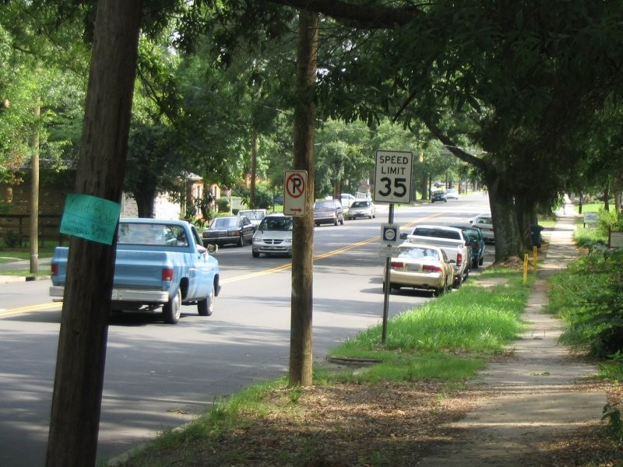
P 1
♦ Observe the picture for exactly 30 seconds. Look at everything you think might be important.
♦ After 30 seconds, answer the questions on the next page on a sheet of paper. (Do not read the questions before you look at the picture!)
♦ Are there cars parked on the sides of the road?
♦ What color is the pickup truck driving in the road?
♦ Any minivans around?
♦ What does the blue sign say?
♦ What's the speed limit?
♦ Are there any pedestrians on the road?
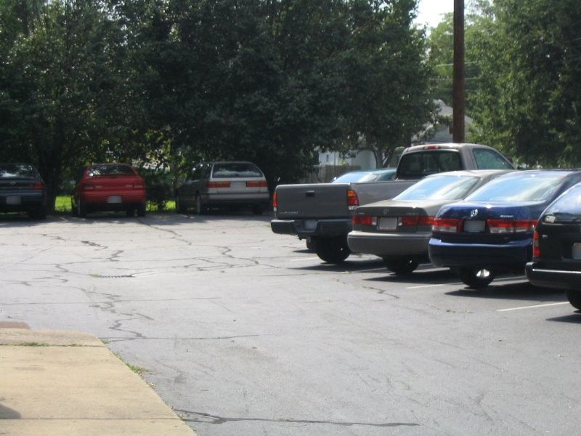
P 2
♦ Choose several people to be observers and choose two people to be investigators.
♦ Allow the observers to look at the picture for 30 seconds. The investigators should not look at the picture.
♦ After 30 seconds, the investigators should begin questioning the observers.
♦ Each Investigator should question each observer. Then, the Investigators should attempt to reconstruct the scene based on the "eyewitness testimony".
Investigators can use these questions to guide their inquiry, but may also think of their own questions.

♦ About how many cars can you see?
♦ Can you describe some of the cars in the lot?
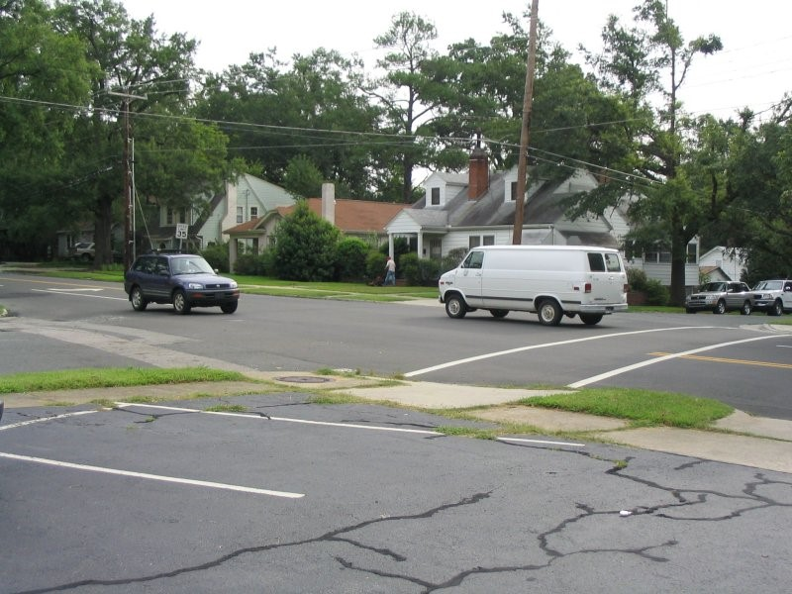
P 3
Investigators can use these questions to guide their inquiry, but may also think of their own questions.

♦ About how many cars can you see?
♦ Can you describe some of the cars in the lot?
♦ How many cars were in the intersection?
♦ Across the street, are there any parked cars on the side?
♦ Can you describe at least one of the cars driving through the intersection? ♦ Are there any other potential witnesses?

If they answer yes, ask the following question:

♦ What was this witness doing?
♦ Where was he? They should have noticed a person mowing a lawn across the street.
♦ What was the speed limit? 35
♦ Was there anyone parked in the first parking spot? No
People
Features
Build
Race
Age
Gender
Hair
height
Vehicles
Feature
Make
Model
Registration Nr
Colour
Year of manufacturer
Description
Objects
Feature
Description
Peculiar features
Condition

Requirements achieved | YES |  | NO
Comments in support of decision
_______________________________________________________________________
_______________________________________________________________________
_______________________________________________________________________
_______________________________________________________________________
_______________________________________________________________________
_______________________________________________________________________
_______________________________________________________________________

LEARNER ACTIVITY 13

CASE STUDY: Read the case study below and record the situation on the attached documentation.

♦ OB

Obtain all the necessary information from the case study below. The documentation needs to be complete and contain all the necessary and correct information as outlined in the case study.

The sound of thunder and bright flashes in the sky may have been a wonderful spectacle last night, but what I didn’t realize was that it would cause one of the worst days of my life. I did not know about the power failure at three this morning because I was fast asleep. The first time I realized that my alarm did not go off, was at ¼ past five this morning – which meant that I was going to be late for work. I rushed while getting dressed and did not have time to iron my uniform because I had to run to get the last taxi. In my haste I forgot to put my pocket book in my pocket, and I could not find my shoes, so I wore takkies instead.

I actually made it to work, only 7 minutes late. My co-worker that had just finished night shift was not very impressed with me because he still had to do the handover. He was going to miss his taxi and would have to wait at least ½ hour for the next one. Because I felt guilty about coming late, I told him to go – I would read the OB to get the details of the night shift….

It looked like things were eventually settling down to a normal, boring working day. Cars stop, “morning sir”, “who are you visiting sir”, “that would be at block C – second building on the left”, “have a nice day sir”. The same thing, over and over. Sometimes I feel like a tape recorder. Cars come, cars go.

In the mean time I’m still a bit unsettled from all the rushing around this morning and tired from lack of sleep because I had to settle the kids down who were crying because they’re scared of the thunder and lightning.

Then the blue BMW stops at the gate about 09:20 . He hoots. So I wasn’t quite as observant as I am supposed to be – I am tired, you know. I paste my smile on my face and walk up to the driver’s window.

I get as far as saying: “Good morning, Sir.”

“Good? – good???; so what’s good about it?”

“Where is Mr. Brown? It’s ten past nine. These $%# taxis! They caused an accident that has made me late! Open this #%^ boom!
“Sir”, I say, “I have to search your vehicle before you enter.” And I think to myself that this guy is so rude - I haven’t done anything to him!

“Never mind about my boot, open this gate, you $|%&*@& “%&*(%$(*%$*%)@*”

By now I’m getting very upset. Who does he think he is to swear at me and call me names? I’ll show him….

“Sir, please get out of your vehicle and open the boot. I will not let you pass until I have searched your vehicle!” I tell him.

“Yes, you *%(%^(%#*% - I’ll get out” - he swears at me again. Now he’s done it. There’s no way that someone insults my mother like that and gets away with it. I will search every inch of his car, and today is the day that he will not pass my boom.

He gets out of the car, and that’s the last thing I remember before I see my supervisor’s face and feel him shaking me. I am lying on the ground, and the boom is pointing up into the sky with blue BMW paint all over it. My jaw hurts like hell…

Occurrence book entry
Dag en datum:
Day of week and date: 15 May 2008
 |  | AARD VAN VOORVAL/NATURE OF OCCURRENCE
VOLG Nr. SERIAL No. | TYD TIME
123 | 09:10 | Patrol back: During the routine patrol it was discovered that a housebreaking and theft occurred at the computer lab. The housebreaking and theft was reported to Mr.  Maseko the security manager on duty.
 |  | Mr. Maseko determined that a Mecer laptop was stolen (asset number 4342222) The incident was reported to the SAPS.
 |  | The SAPS Reference number is SAPS S/Side 123/08/2005. The investigation officer is inspector Botha(012) 321 4333.,
 |  | Signed: J Ramoba
You are escorting Me Sithole from the control room to Mr Bembe the Financial Director of the company on 20 July 2006 at 14:00. You arrived at 14:30 at Mr Bembe’s office. On the way Mr Sithole complains about walking all the way to Mr Bembe. Use the information in the case study to make an entry in your ‘pocket book’.

Pocket book entry
2007/05/15  06:00 | Housebreaking and Theft Report: On 2007/05/15 at 069:00 during a routine patrol I discovered a housebreaking and theft at the computer lab of Building BB. No suspects or witnesses could have been identified. I secured the crime scene and no one was allowed to enter the scene.
I reported the matter to Mr Maseko my security manager, and the SAPS investigated the crime scene. SR Reference Number 13/08/2005 and OB Reference Number 123/05/2007.

Signed: J Ramoba

LEARNER ACTIVITY 14

How should a security officer deal with a member of the public.
_______________________________________________________________________
_______________________________________________________________________
_______________________________________________________________________
_______________________________________________________________________
_______________________________________________________________________
_______________________________________________________________________
_______________________________________________________________________
_______________________________________________________________________
Requirements achieved | YES |  | NO
Comments in support of decision
_______________________________________________________________________
_______________________________________________________________________
_______________________________________________________________________
_______________________________________________________________________
_______________________________________________________________________
_______________________________________________________________________
_______________________________________________________________________ SELF-ASSESSMENT

The learner must make use of the following self-evaluation checklist to rate himself against the learning outcomes of this particular training module in establishing the level of mastery of the information.

- Not able to comply

- Reasonable compliance (Not acceptable for final evaluation)

- Able to comply fully
 | LEARNING OUTCOMES | 1 | 2 | 3
1 | Operate and maintain an access/egress control site in accordance with the relevant legal requirements and workplace procedures.
2 | Conduct access/egress control o people, vehicles and goods per workplace procedures.
3 | Operate site-specific equipment in accordance with workplace procedures and manufacturer’s specifications.
4 | Deal with unauthorized/authorized people, vehicles and goods as per workplace procedures and relevant legal requirements.
5 | Handle emergencies and irregularities according to workplac3e procedures and contingency plans.
6 | Ensure appropriate interpersonal skills for effective customer relationships.

_____________________________________ ________________________ Evidence Collector Signature Date

_____________________________________ ________________________
Security Officer Signature Date

LEARNING UNIT 3

Legal compliance

LEARNING OUTCOMES

A learning credited with this unit will be able to:

1. Understand the relevant legislation, policies and regulations required for lawful searching, detention and/or seizure of people, vehicles and goods.

LEARNER ACTIVITY 1

What are the articles that can be seized from an arrestee after an arrest has been made according to Article 20 of the Criminal Procedures Act 51 of 1977.
_______________________________________________________________________
_______________________________________________________________________
_______________________________________________________________________
_______________________________________________________________________
_______________________________________________________________________
_______________________________________________________________________
_______________________________________________________________________
_______________________________________________________________________
Requirements achieved | YES |  | NO
Comments in support of decision
_______________________________________________________________________
_______________________________________________________________________
_______________________________________________________________________
_______________________________________________________________________
_______________________________________________________________________
_______________________________________________________________________
_______________________________________________________________________

LEARNER ACTIVITY 2

Study the case study below and answer the relevant answers.

During the morning shift a elderly man with a 4 year old boy holding his hand approach you to obtain access to the building.

It looked very suspiciously due to a big briefcase that the old man is holding. When you asked if you can help the boy replied “ My grandpa can not talk can I help you” You o n return asked to search the elderly man, boy and briefcase.

The boy then replied again. “yes you can search my grandpa but not me.

♦ Discuss the procedure that you should follow in this case.
♦ Also explain if the consent given by the boy are legal or not. Motivate your answer by discussing the requirements of consent.
♦ You found a firearm during your search!! What should you do?
♦
_______________________________________________________________________
_______________________________________________________________________
_______________________________________________________________________
_______________________________________________________________________
_______________________________________________________________________
_______________________________________________________________________
_______________________________________________________________________
_______________________________________________________________________
_______________________________________________________________________
_______________________________________________________________________
_______________________________________________________________________ _______________________________________________________________________
_______________________________________________________________________
_______________________________________________________________________
_______________________________________________________________________
_______________________________________________________________________
_______________________________________________________________________
_______________________________________________________________________
_______________________________________________________________________
_______________________________________________________________________
_______________________________________________________________________
_______________________________________________________________________
_______________________________________________________________________
_______________________________________________________________________
_______________________________________________________________________
_______________________________________________________________________
_______________________________________________________________________
_______________________________________________________________________
_______________________________________________________________________
_______________________________________________________________________
_______________________________________________________________________ _______________________________________________________________________
_______________________________________________________________________
_______________________________________________________________________
_______________________________________________________________________
_______________________________________________________________________
_______________________________________________________________________
_______________________________________________________________________
_______________________________________________________________________
_______________________________________________________________________
_______________________________________________________________________
_______________________________________________________________________
_______________________________________________________________________
_______________________________________________________________________
_______________________________________________________________________
_______________________________________________________________________
_______________________________________________________________________
_______________________________________________________________________
_______________________________________________________________________
_______________________________________________________________________
_______________________________________________________________________

Requirements achieved | YES |  | NO
Comments in support of decision
Customer valuable and firearm register |  |  |  |  |  |  | Pg Nr ...
Date | Name | Telephone | Firearm type / valuable item | Firearm  nr / valuable item nr | Owner signature |  | Access control security officer signature | Key Nr
 |  |  |  |  | In | Out | Access control security officer signature | Key Nr

_______________________________________________________________________
Where details does not appear in the case
study, request it from the assessor.
_______________________________________________________________________
_______________________________________________________________________
_______________________________________________________________________
_______________________________________________________________________
_______________________________________________________________________

LEARNER ACTIVITY 3

Provide detail explanation of the following:

♦ The meaning of premises as defined in the act.
♦ Dangerous object
♦ Authorized officer
♦ “Women searching a women”
♦ Reasonableness
_______________________________________________________________________
_______________________________________________________________________
_______________________________________________________________________
_______________________________________________________________________
_______________________________________________________________________
_______________________________________________________________________
_______________________________________________________________________
_______________________________________________________________________
_______________________________________________________________________
_______________________________________________________________________
_______________________________________________________________________
_______________________________________________________________________
_______________________________________________________________________
_______________________________________________________________________
_______________________________________________________________________ _______________________________________________________________________
_______________________________________________________________________
_______________________________________________________________________
_______________________________________________________________________
_______________________________________________________________________
_______________________________________________________________________
_______________________________________________________________________
_______________________________________________________________________
_______________________________________________________________________
_______________________________________________________________________
_______________________________________________________________________
_______________________________________________________________________
_______________________________________________________________________
_______________________________________________________________________
_______________________________________________________________________
_______________________________________________________________________
_______________________________________________________________________

_______________________________________________________________________
_______________________________________________________________________
_______________________________________________________________________
_______________________________________________________________________
_______________________________________________________________________
_______________________________________________________________________
_______________________________________________________________________
_______________________________________________________________________
_______________________________________________________________________
_______________________________________________________________________
_______________________________________________________________________
_______________________________________________________________________
_______________________________________________________________________
_______________________________________________________________________
_______________________________________________________________________
_______________________________________________________________________
_______________________________________________________________________ _______________________________________________________________________
_______________________________________________________________________
_______________________________________________________________________
_______________________________________________________________________
_______________________________________________________________________
_______________________________________________________________________
_______________________________________________________________________
_______________________________________________________________________
Requirements achieved | YES |  | NO
Comments in support of decision
_______________________________________________________________________
_______________________________________________________________________
_______________________________________________________________________
_______________________________________________________________________
_______________________________________________________________________
_______________________________________________________________________
_______________________________________________________________________

LEARNER ACTIVITY 4

Explain the manner in which an search needs to be conducted.
_______________________________________________________________________
_______________________________________________________________________
_______________________________________________________________________
_______________________________________________________________________
_______________________________________________________________________
_______________________________________________________________________
_______________________________________________________________________
_______________________________________________________________________
_______________________________________________________________________
_______________________________________________________________________
_______________________________________________________________________
_______________________________________________________________________
_______________________________________________________________________
_______________________________________________________________________
_______________________________________________________________________
_______________________________________________________________________
_______________________________________________________________________
_______________________________________________________________________

_______________________________________________________________________
_______________________________________________________________________
_______________________________________________________________________
_______________________________________________________________________
_______________________________________________________________________
_______________________________________________________________________
_______________________________________________________________________
_______________________________________________________________________
_______________________________________________________________________
_______________________________________________________________________
Requirements achieved | YES |  | NO
Comments in support of decision
_______________________________________________________________________
_______________________________________________________________________
_______________________________________________________________________
_______________________________________________________________________
_______________________________________________________________________
_______________________________________________________________________
_______________________________________________________________________ SELF-ASSESSMENT

The learner must make use of the following self-evaluation checklist to rate himself against the learning outcomes of this particular training module in establishing the level of mastery of the information.

- Not able to comply

- Reasonable compliance (Not acceptable for final evaluation)

- Able to comply fully
 | LEARNING OUTCOMES | 1 | 2 | 3
1 | Understand the relevant legislation, policies and regulations required for lawful searching, detention and/or seizure of people, vehicles and goods.

_____________________________________ ________________________ Evidence Collector Signature Date

_____________________________________ ________________________
Security Officer Signature Date

LEARNING UNIT 4

Searching of people, vehicles
and goods

LEARNING OUTCOMES

A learning credited with this unit will be able to:

- Search people, vehicles and goods making use of relevant methods and equipment.
- Explain the procedures of handing over of unauthorized people, vehicles or goods.
- Complete and verify all relevant documentation of an incident.

LEARNER ACTIVITY 1

Study the images below and indicate where a search should take place.

Label the images starting with one
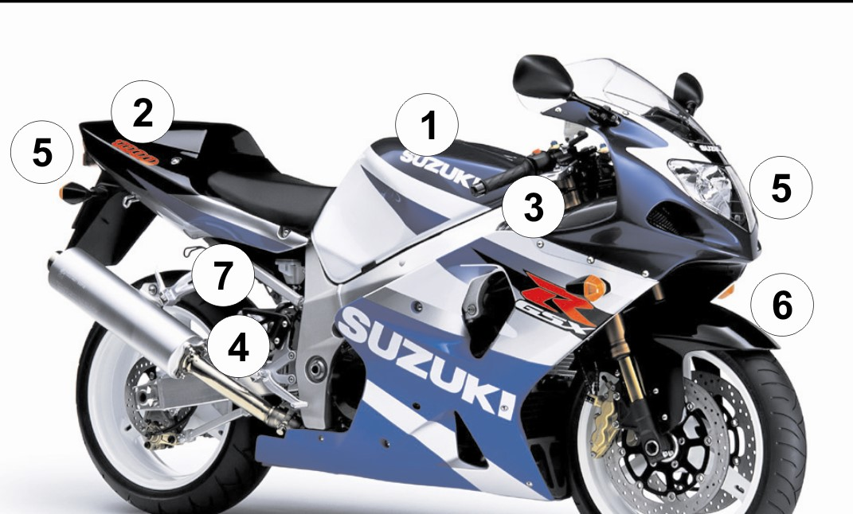
1.
2.
3.
4.
5.
6.
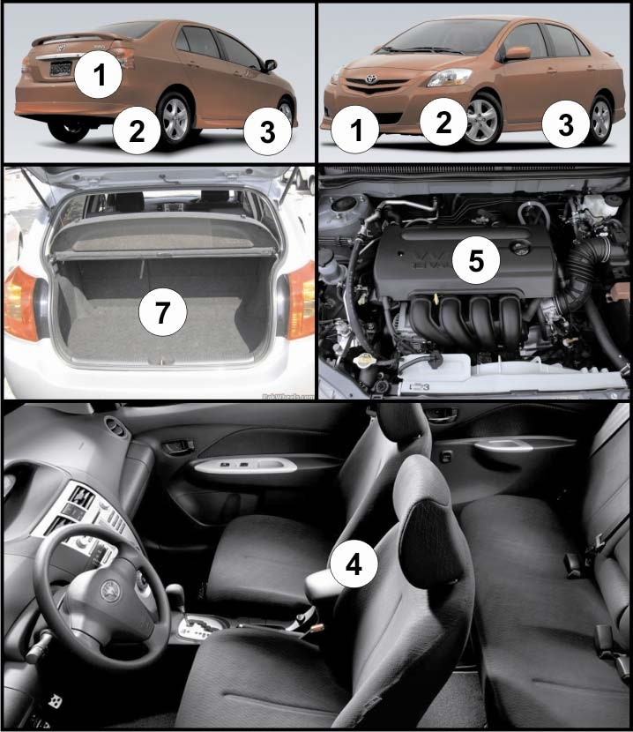
1.
2.
3.
4.
5.
6.
7.
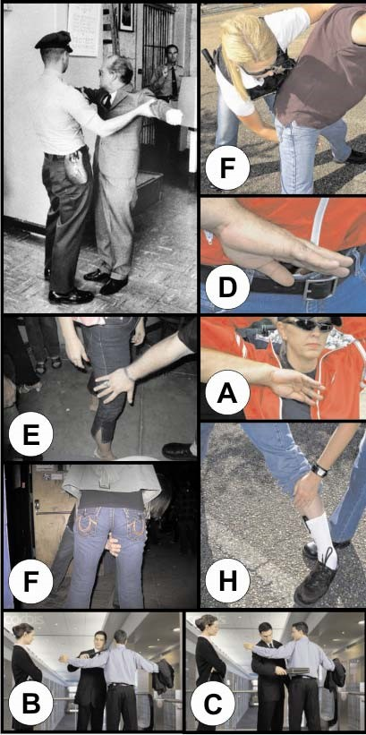
A.
B.
C.
D.
E.
F.
G.
H.

LEARNER ACTIVITY 2

When searching a vehicle, person or a briefcase a security officer needs to know what he is looking for. List those critical factors that a security officer always needs to lookout for.
_______________________________________________________________________
_______________________________________________________________________
_______________________________________________________________________
_______________________________________________________________________
_______________________________________________________________________
_______________________________________________________________________
_______________________________________________________________________
_______________________________________________________________________
Requirements achieved | YES |  | NO
Comments in support of decision
_______________________________________________________________________
_______________________________________________________________________
_______________________________________________________________________
_______________________________________________________________________
_______________________________________________________________________
_______________________________________________________________________
_______________________________________________________________________

LEARNER ACTIVITY 3

When the search is completed, the person should be requested to produce his or her identity document or any official document in his or her possession. The identity documents should be checked carefully and compared with the person by means of the following guidelines, Photograph, stamps and condition of the document. Explain how these should be checked.
_______________________________________________________________________
_______________________________________________________________________
_______________________________________________________________________
_______________________________________________________________________
_______________________________________________________________________
_______________________________________________________________________
_______________________________________________________________________
_______________________________________________________________________
_______________________________________________________________________
_______________________________________________________________________
_______________________________________________________________________
_______________________________________________________________________
_______________________________________________________________________
_______________________________________________________________________ _______________________________________________________________________
_______________________________________________________________________
_______________________________________________________________________
_______________________________________________________________________
_______________________________________________________________________
_______________________________________________________________________
_______________________________________________________________________
_______________________________________________________________________
Requirements achieved | YES |  | NO
Comments in support of decision
_______________________________________________________________________
_______________________________________________________________________
_______________________________________________________________________
_______________________________________________________________________
_______________________________________________________________________
_______________________________________________________________________
_______________________________________________________________________

LEARNER ACTIVITY 4

What should be the two main characteristics of the questions asked of the person being searched?
_______________________________________________________________________
_______________________________________________________________________
_______________________________________________________________________
_______________________________________________________________________
_______________________________________________________________________
_______________________________________________________________________
_______________________________________________________________________
_______________________________________________________________________
Requirements achieved | YES |  | NO
Comments in support of decision
_______________________________________________________________________
_______________________________________________________________________
_______________________________________________________________________
_______________________________________________________________________
_______________________________________________________________________
_______________________________________________________________________
_______________________________________________________________________

LEARNER ACTIVITY 5

What are the general rules when you search someone?
_______________________________________________________________________
_______________________________________________________________________
_______________________________________________________________________
_______________________________________________________________________
_______________________________________________________________________
_______________________________________________________________________
_______________________________________________________________________
_______________________________________________________________________
Requirements achieved | YES |  | NO
Comments in support of decision
_______________________________________________________________________
_______________________________________________________________________
_______________________________________________________________________
_______________________________________________________________________
_______________________________________________________________________
_______________________________________________________________________
_______________________________________________________________________

LEARNER ACTIVITY 6

When searching employees during egress control, there is a certain procedure to follow - (this can be adapted depending on the site). List all of them.
_______________________________________________________________________
_______________________________________________________________________
_______________________________________________________________________
_______________________________________________________________________
_______________________________________________________________________
_______________________________________________________________________
_______________________________________________________________________
_______________________________________________________________________
Requirements achieved | YES |  | NO
Comments in support of decision
_______________________________________________________________________
_______________________________________________________________________
_______________________________________________________________________
_______________________________________________________________________
_______________________________________________________________________
_______________________________________________________________________
_______________________________________________________________________

LEARNER ACTIVITY 7

What do you have to keep in mind when searching a vehicle?
_______________________________________________________________________
_______________________________________________________________________
_______________________________________________________________________
_______________________________________________________________________
_______________________________________________________________________
_______________________________________________________________________
_______________________________________________________________________
_______________________________________________________________________
Requirements achieved | YES |  | NO
Comments in support of decision
_______________________________________________________________________
_______________________________________________________________________
_______________________________________________________________________
_______________________________________________________________________
_______________________________________________________________________
_______________________________________________________________________
_______________________________________________________________________

LEARNER ACTIVITY 8

Study the image below and explain procedure to follow when searching a vehicle. Base your explanation of the procedures on the scenario below (image)
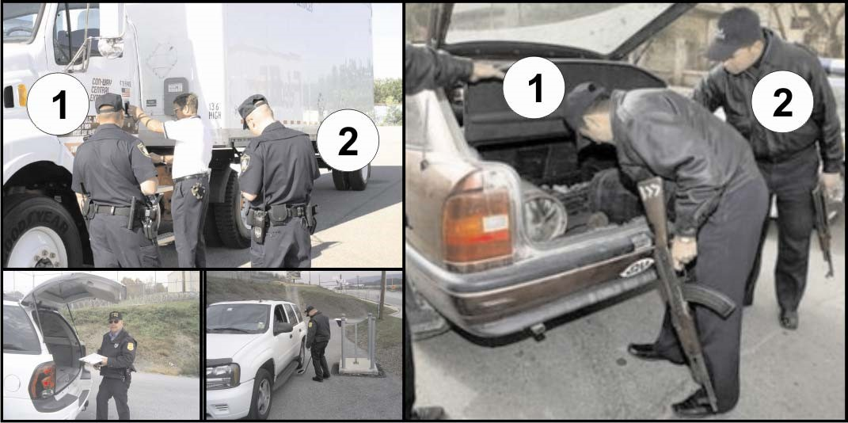
_______________________________________________________________________
_______________________________________________________________________
_______________________________________________________________________
_______________________________________________________________________
_______________________________________________________________________
_______________________________________________________________________
_______________________________________________________________________
_______________________________________________________________________
_______________________________________________________________________ _______________________________________________________________________
_______________________________________________________________________
_______________________________________________________________________
_______________________________________________________________________
_______________________________________________________________________
_______________________________________________________________________
_______________________________________________________________________
_______________________________________________________________________
_______________________________________________________________________
_______________________________________________________________________

Requirements achieved | YES |  | NO
Comments in support of decision
_______________________________________________________________________
_______________________________________________________________________
_______________________________________________________________________
_______________________________________________________________________
_______________________________________________________________________
_______________________________________________________________________ SELF-ASSESSMENT

The learner must make use of the following self-evaluation checklist to rate himself against the learning outcomes of this particular training module in establishing the level of mastery of the information.

- Not able to comply

- Reasonable compliance (Not acceptable for final evaluation)

- Able to comply fully
 | LEARNING OUTCOMES | 1 | 2 | 3
1 | Search people, vehicles and goods making use of relevant methods and equipment.
2 | Explain the procedures of handing over of unauthorized people, vehicles or goods.
3 | Complete and verify all relevant documentation of an incident.

_____________________________________ ________________________ Evidence Collector Signature Date

_____________________________________ ________________________
Security Officer Signature Date

LEARNING UNIT 5

Escorting

LEARNING OUTCOMES

A learning credited with this unit will be able to:

- Identify the threat before undertaking an escort.
- Name the resource requirements during escorting.
- List the different security tasks during escorting.
- Explain the actions for planning and preparing for escorting.
- List the criteria when planning a route map and explain the steps when planning a route map.
- Explain contingency plans for valuables, persons or suspects.
- Identify all valuables/persons or suspects to be escorted.
- Determine classification / recent behaviour of valuables / persons or suspects and identify special needs when preparing for escort assignments.
- Perform suspect search when required according to relevant legislation.

LEARNER ACTIVITY 1

You have to escort a suspect from the control room to a police station and you have to do a threat assessment. You will need certain knowledge with regard to the threat before you can do the threat assessment. What would that be?
_______________________________________________________________________
_______________________________________________________________________
_______________________________________________________________________
_______________________________________________________________________
_______________________________________________________________________
_______________________________________________________________________
_______________________________________________________________________
_______________________________________________________________________
Requirements achieved | YES |  | NO
Comments in support of decision
_______________________________________________________________________
_______________________________________________________________________
_______________________________________________________________________
_______________________________________________________________________
_______________________________________________________________________
_______________________________________________________________________
_______________________________________________________________________

LEARNER ACTIVITY 2

You have received an operational instruction to escort valuables from the control room of your company to the human resource department. The valuables will arrive at the control room on Tuesday, 12 July 2006 at 09:00. You have to escort the valuables from the control room to Mr Strydom. Before you can undertake the escort, you have to do a complete threat assessment. Discuss the steps that you will follow when doing a threat assessment. (Guidelines for progression of the threat assessment)
_______________________________________________________________________
_______________________________________________________________________
_______________________________________________________________________
_______________________________________________________________________
_______________________________________________________________________
_______________________________________________________________________
_______________________________________________________________________
_______________________________________________________________________
Requirements achieved | YES |  | NO
Comments in support of decision
_______________________________________________________________________
_______________________________________________________________________
_______________________________________________________________________
_______________________________________________________________________
_______________________________________________________________________
_______________________________________________________________________

_______________________________________________________________________Learner workbook

LEARNER ACTIVITY 3

You have received an operation instruction and you have to escort a truck with mine debris or waste. The threat has already been identify that suspects might “hijack” the truck. Evaluate the identified threat. You are also allowed to use site-related examples.
_______________________________________________________________________
_______________________________________________________________________
_______________________________________________________________________
_______________________________________________________________________
_______________________________________________________________________
_______________________________________________________________________
_______________________________________________________________________
_______________________________________________________________________
Requirements achieved | YES |  | NO
Comments in support of decision
_______________________________________________________________________
_______________________________________________________________________
_______________________________________________________________________
_______________________________________________________________________
_______________________________________________________________________
_______________________________________________________________________
_______________________________________________________________________

LEARNER ACTIVITY 4

There are three different types of escorting. Name the different types of escorting and give examples in your answer (you are allowed to give site related examples).
_______________________________________________________________________
_______________________________________________________________________
_______________________________________________________________________
_______________________________________________________________________
_______________________________________________________________________
_______________________________________________________________________
_______________________________________________________________________
_______________________________________________________________________
Requirements achieved | YES |  | NO
Comments in support of decision
_______________________________________________________________________
_______________________________________________________________________
_______________________________________________________________________
_______________________________________________________________________
_______________________________________________________________________
_______________________________________________________________________
_______________________________________________________________________

LEARNER ACTIVITY 5

Escorting can take place on foot or by vehicle. Explain when you would do an escort on foot and when you would do an escort with a vehicle.
_______________________________________________________________________
_______________________________________________________________________
_______________________________________________________________________
_______________________________________________________________________
_______________________________________________________________________
_______________________________________________________________________
_______________________________________________________________________
_______________________________________________________________________
Requirements achieved | YES |  | NO
Comments in support of decision
_______________________________________________________________________
_______________________________________________________________________
_______________________________________________________________________
_______________________________________________________________________
_______________________________________________________________________
_______________________________________________________________________
_______________________________________________________________________

LEARNER ACTIVITY 6
Complete the following table with regard to determining the special needs or requirements for escort. Fill in the missing information.

♦ Category 1:
♦ Suspects:
♦ Category 3:

How should the goods be handled, packed, transported and delivered?
_______________________________________________________________________
_______________________________________________________________________
_______________________________________________________________________
_______________________________________________________________________
_______________________________________________________________________
_______________________________________________________________________
_______________________________________________________________________
_______________________________________________________________________
Requirements achieved | YES |  | NO
Comments in support of decision
_______________________________________________________________________
_______________________________________________________________________
_______________________________________________________________________
_______________________________________________________________________
_______________________________________________________________________ SELF-ASSESSMENT

The learner must make use of the following self-evaluation checklist to rate himself against the learning outcomes of this particular training module in establishing the level of mastery of the information.

- Not able to comply

- Reasonable compliance (Not acceptable for final evaluation)

- Able to comply fully
 | LEARNING OUTCOMES | 1 | 2 | 3
1 | Identify the threat before undertaking an escort.
2 | Name the resource requirements during escorting.
3 | List the different security tasks during escorting.
4 | Explain the actions for planning and preparing for escorting.
5 | List the criteria when planning a route map and explain the steps when planning a route map.
6 | Explain contingency plans for valuables, persons or suspects.
7 | Identify all valuables/persons or suspects to be escorted.
8 | Determine classification / recent behaviour of valuables / persons or suspects and identify special needs when preparing for escort assignments.
9 | Perform suspect search when required according to relevant legislation.

_____________________________________ ________________________ Evidence Collector Signature Date

_____________________________________ ________________________
Security Officer Signature Date

